Dipannita Adhikary

Diploma in Computer Science & Technology Engineering

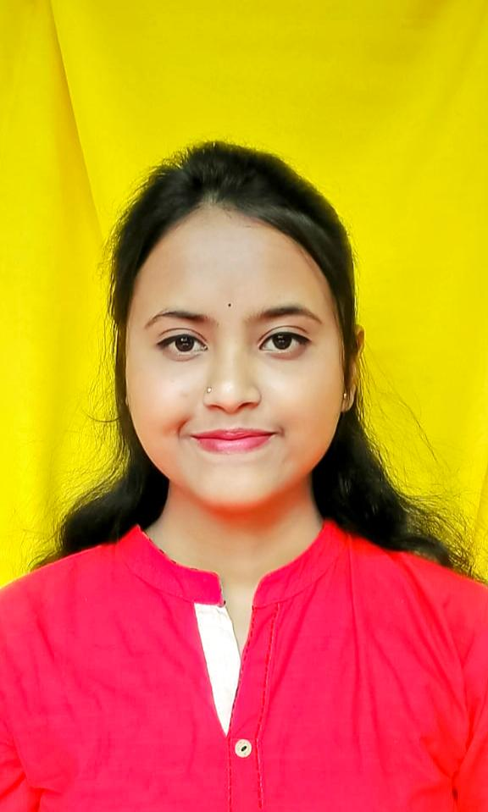

Contact

**Address:**

Nungi Benepara, Batanagar,

Maheshtala, South24 pgs

**Phone:**

+91 9007749403

**Email:**

Adhikarydipa452@gmain.com

**DOB:** 22/02/2003

Languages

Bengali

English

Hindi

Career Objective

To build up career in challenging and rewarding position at a well reputated company where creativity, sincerity, skill and perfomance are the criteria for one’s appraisal and recognition and provides me suitable opportunity to grow my technical and communication skills which would help me to grow while working towards the organization goals . The situation when the huge work pressuure arises is the time to prove myself best. If you are looking for me, I’m here for you.

Skill Highlights

|  |  |
| --- | --- |
| * Positive Mentality * Strong Decision Maker * Hard worker | * Quick Learner * Teamworker |

Education

1. Completed **Diploma in Computer Science & Technology** from Acharyya Prafulla Chandra Roy Polytechnic.

(SEM 1 : CGPA-9.1 SEM 2 : CGPA-9.6 SEM 3 : CGPA – 8.9 SEM 4 : CGPA -8.3 SEM 5 : 8.5 SEM 6 :8.8)

OVERALL PERCENTAGE : 84.4

OVERALL CGPA : 8.9

1. Passed **Higher Secondary Examination** from Batanagar Girl’s High School in **2020**.With 90.4% marks.
2. Passed **Madhyamic (Secondary) Examination** from Batanagar Girl’s High School in **2018**.With 72.14% marks.

Experience

1. Fresher

Area of Interests

1. Watching Movies
2. Meeting Unknown People
3. Planting Trees

Computer Languages

i. Python ii. C iii. Java

iv. PHP v.Html